Here to Buy Repairs Ltd
Source of Referral: FB Web Other ____________________________
Date: Time : Name:
Contact Telephone:
Manufacturer: Model:
Network:
Repair Requested :
Phone’s Numeric Password: (for testing after repair)
Phone’s Pattern Password
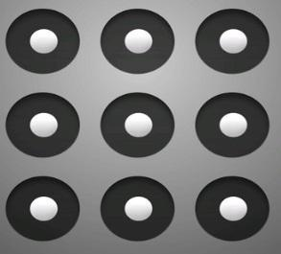
1. IF WE SUCCESSFULLY REPAIR YOUR PHONE & THE PHONE TURNS OUT TO BE BARRED THE QUOTED REPAIR PRICE WILL STILL STAND.
2. WE ONLY REPAIR THE FAULT THAT YOUR PHONE CAME IN FOR, IF WE REPAIR THE PHONE & ON TESTING WE NOTICE IT HAS ADDITIONAL FAULTS, YOU WILL BE QUOTED SEPERATELY FOR THOSE FAULTS.
3. WE ADVISE ALL DATA IS BACKED UP PRIOR TO REPAIR AS WE CANNOT BE HELD RESPONSIBLE FOR ANY DATA LOST.
4. ALL DEVICES ARE TESTED BEFORE THE REPAIRS ARE CARRIED OUT. IF ANY ADDITIONAL FAULTS ARE FOUND THAT HAVE NOT BEEN DESCRIBED WE WILL CEASE THE REPAIR UNTIL WE HAVE DISCUSSED THIS FURTHER WITH YOU.
5. ANY PHONES THAT HAVE NOT BEEN PAID FOR WITHIN 90 DAYS OF BEING REPAIRED OR CLASSED AS B.E.R (BEYOND ECONOMICAL REPAIR), WILL BE DISPOSED OF OR BROKEN DOWN FOR PARTS. 5. HERE TO BUY REPAIRS LTD ADVISE CUSTOMERS TO BACK UP ALL DATA BEFORE DROPPING OFF YOUR DEVICE FOR REPAIR.
6. IF PASSCODES ARE NOT GIVEN WE CANNOT WARRANTY THE JOB COMPLETED AS WE ARE UNABLE TO TEST THE DEVICE.

I HAVE READ AND UNDERSTOOD THESE TERMS AND CONDITIONS

SIGNED DATE

For Office use: Signature
Camera F B Speaker Mic Volume Mute Power

